All About the Family

Some families are large,
Some families are small,
But I love my family
Best of all!

Background information

My family name is ___________________________________

My first name is ____________________________________

I live in ____________________, _____________________
town or city state

My address is ______________________________________
_________________________________________________
_________________________________________________

My phone number is ____________________________

My birthday is ________________________________
month day

I was born in _______________________, ________________.
town or city country

In my family I am the

oldest child middle child
youngest child only child

I have _______ sisters and _______ brothers.

My special name or nickname is _________________________.

The People in my Family

Name Relationship

My Family Tree

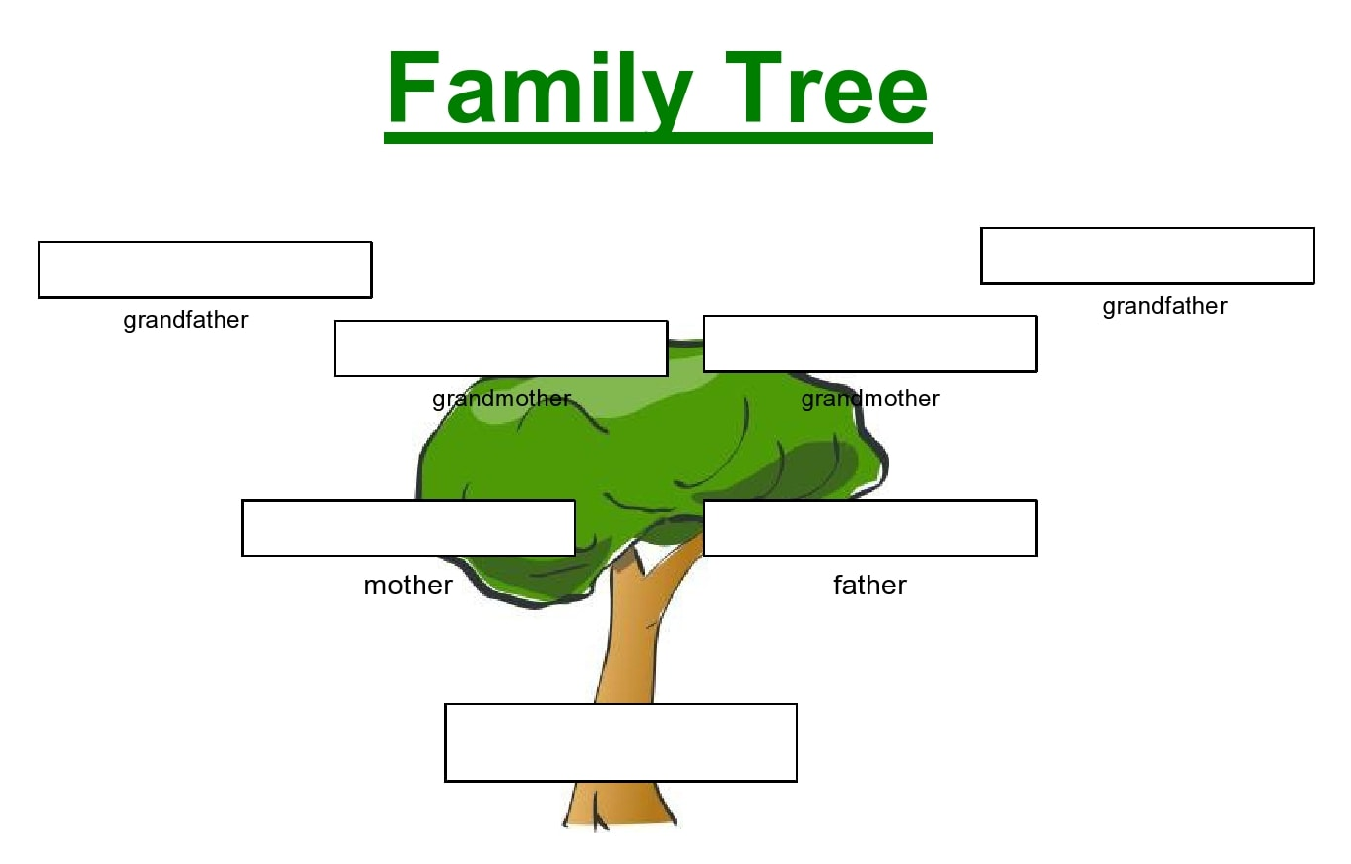

Write family members’ names on the tree or create your own chart below.

Biographical Information About
(Your Name)

Write information about your education, military service, marriage, children, illnesses, residences, jobs, family events, deaths, and other important events in your life.

Date | Age | Event and Place

Picture of Me
Picture of My Family
My Family History

Share this Information with a Partner

Who lived in your home with you as a child?
How many brothers or sisters lived there?
What other people lived there?

Describe your father or mother as you remember looking at them when you were small.

Did anyone in the family have some unusual characteristics?

Who visited your home when you were young?

Who were your neighbors?

What did your family do together?
A Special Person in my Family

__________________________ is special because….

Family Names and their Meanings

What does your name mean?

Who chose your name?
Why?

My Address is

Street: _____________________________________________________
Apt./suite no. __________________
City: __________________ State: __________ ZIP Code: _______________

I am moving.

Submit a change of address form at the Post Office.

NAME

First: __________________ Middle: ______ Last: ____________________

OLD Address

Street: _____________________________________________________
Apt./suite no. __________________
City: __________________ State: __________ ZIP Code: _______________

NEW Address:

Street: _____________________________________________________
Apt./suite no. __________________
City: __________________ State: __________ ZIP Code: _______________

The Place I Came From

Mark your country on the map.

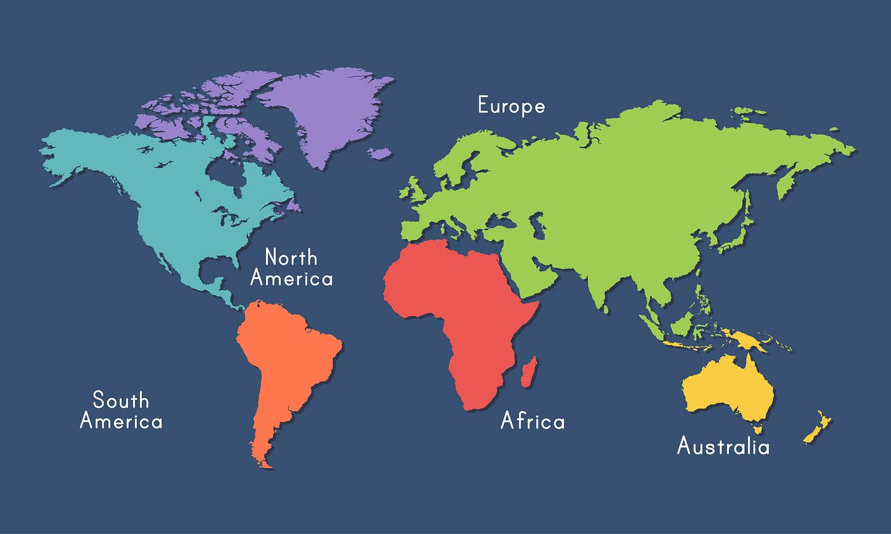

What I Miss Most About My Country

Places I Have Lived

city or town country

My Telephone

My telephone number is: ______________________

Practice recording a message in English for your voicemail.

Some examples:

“Hi. This is _____________(your name). I am sorry I missed your call. Please leave a message and I will call you back.”

“Hello. You have called the _________________ (your last name). I can’t take your call right now but leave a message and your call will be returned.”

“Hello. This is ______________________ (your phone number). Please leave your name and number and I will call you as soon as I can. Have a nice day!”
My Important Telephone Numbers

Name Number

My Usual Day Looks Like This

6:00 a.m.
6:30 a.m.
7:00 a.m.
7:30 a.m.
8:00 a.m.
8:30 a.m.
9:00 a.m.
9:30 a.m.
10:00 a.m.
10:30 a.m.
11:00 a.m.
11:30 a.m.
12:00 p.m.
12:30 p.m.
1:00 p.m.
1:30 p.m.
2:00 p.m.
2:30 p.m.
3:00 p.m.
3:30 p.m.
4:00 p.m.
4:30 p.m.
5:00 p.m.
5:30 p.m.
6:00 p.m.
6:30.p.m.
7:00 p.m.
7:30 p.m.
8:00 p.m.
8:30 p.m.
9:00 p.m.
9:30 p.m.
10:00 p.m.
10:30 p.m.
11:00 p.m.
11:30 p.m.
12:00 a.m.

My Usual Week Looks Like This

Week of ____________________ | Activities
Sunday
Monday
Tuesday
Wednesday
Thursday
Friday
Saturday
My Usual Month Looks Like This

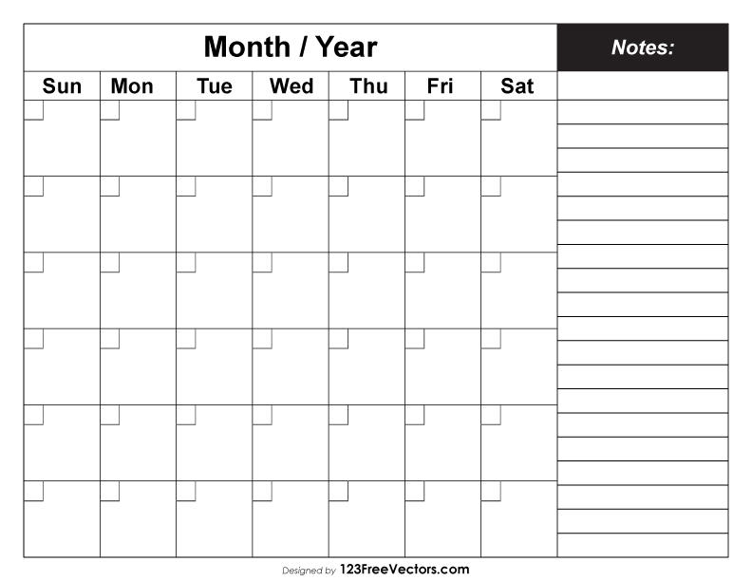
Special Days

One special day for me is _________________________________

because

Other holidays in my country are:

Important Events of My Life

About Me

Color of hair _______________

My hair is curly straight wavy

Color of eyes _______________

I do do not wear glasses.

Height ______________feet ____________inches

I write with my ______________ hand.

I do do not have freckles.

I live in a house mobile home
apartment condominium

My home is neat just right messy

My best quality is

I have a very good friend whose name is ______________________

My favorite meal is ____________________________________________________

____________________________________________________

My Handwriting

Here is my handwriting on this line.

Name (please print) Signature

You can see a sample of my handwriting on this check.

___________________ 1027
Name
______________________________
Address
______________________________ DATE________________________

PAY TO
THE ORDER OF ______________________________ ________________________ $ _____________

________________________________________________ DOLLARS

Farm Credit Bank
Albany, New York

FOR ____________________________ ______________________________________

: 044002161 37404279 0539

My Friends

What Makes My Family Special

Special Times With My Family

Traditions My Family Celebrate

Things I Do With My Family

Family Events and Celebrations

Circle important dates

January | February | March
Su Mo Tu We Th Fr Sa  1  2 3 4 5 6 7 8  9 10 11 12 13 14 15  16 17 18 19 20 21 22  23 24 25 26 27 28 29  30 31 | Su Mo Tu We Th Fr Sa  1 2 3 4 5  6 7 8 9 10 11 12  13 14 15 16 17 18 19  20 21 22 23 24 25 26  27 28 29 | Su Mo Tu We Th Fr Sa  1 2 3 4 5  6 7 8 9 10 11 12  13 14 15 16 17 18 19  20 21 22 23 24 25 26  27 28 29 30 31
April | May | June
Su Mo Tu We Th Fr Sa  1 2  3 4 5 6 7 8 9  10 11 12 13 14 15 16  17 18 19 20 21 22 23  24 25 26 27 28 29 30 | Su Mo Tu We Th Fr Sa  1 2 3 4 5 6 7  8 9 10 11 12 13 14  15 16 17 18 19 20 21  22 23 24 25 26 27 28  29 30 31 | Su Mo Tu We Th Fr Sa  - 2 3 4  - 6 7 8 9 10 11  12 13 14 15 16 17 18  19 20 21 22 23 24 25  26 27 28 29 30
July | August | September
Su Mo Tu We Th Fr Sa  1 2  3 4 5 6 7 8 9  10 11 12 13 14 15 16  17 18 19 20 21 22 23  24 25 26 27 28 29 30  31 | Su Mo Tu We Th Fr Sa  - 2 3 4 5 6  - 8 9 10 11 12 13  14 15 16 17 18 19 20  21 22 23 24 25 26 27  28 29 30 31 | Su Mo Tu We Th Fr Sa  1 2 3  4 5 6 7 8 9 10  11 12 13 14 15 16 17  18 19 20 21 22 23 24  25 26 27 28 29 30
October | November | December
Su Mo Tu We Th Fr Sa  1  2 3 4 5 6 7 8  9 10 11 12 13 14 15  16 17 18 19 20 21 22  23 24 25 26 27 28 29  30 31 | Su Mo Tu We Th Fr Sa  1 2 3 4 5  6 7 8 9 10 11 12  13 14 15 16 17 18 19  20 21 22 23 24 25 26  27 28 29 30 | Su Mo Tu We Th Fr Sa  1 2 3  4 5 6 7 8 9 10  11 12 13 14 15 16 17  18 19 20 21 22 23 24  25 26 27 28 29 30 31
Choose a Topic and Talk to a Partner

Describe the house in which you lived when you were a child.

Tell about the room you slept in when you were a child.

Describe the houses in your neighborhood.

Describe your favorite place to visit when you were a child.

Where did you go to school? What was in the classrooms?

Describe where you went to shop for food.

Where did you go for fun and recreation?

Did your family ever move?

Describe the house you lived in when you were first married.

What kind of utensils did you have in the kitchen?
What Family Means To Me

Fabulous Family Member Award

Give someone in your family the Fabulous Family Member Award.


Fabulous
Family
Member

This award goes to ________________________
for _____________________________________
________________________________________
________________________________________
My Family Treasures

Ideas for Families

My Astrology Sign

The year I was born in

What does this mean?

Map of my Home
Map of my Neighborhood
Graph of my Family Members

Edit the bar graph to show the heights or ages of your family members.

Things That Make Me Happy
Make a list and share them with a partner.
1.

2.

3.

4.

5.

6.

7.

8.

9.

10.

Things that make other people happy.

Would they make you happy?

Moonlight
Fall leaves blowing in the wind
Puppy dogs
Ice cream
Snow
Babies laughing
The sound of birds
Flowers
Visiting a friend
Watching butterflies
Strawberries
A hot shower
No line at the grocery store
A long-distance phone call
Hot chocolate

Make a List

People in my family

My favorite foods

My grocery list

My emergency phone numbers

My list of things to do

My favorite places to visit

People who are important to me

Important events in my life

Things I want to do this week/year/lifetime

Things that are important to me

My strengths and weaknesses

My priority list

What Is In Your Refrigerator?

Mark what is in your refrigerator. Then ask a classmate and your teacher what is in their refrigerators.

You Your classmate Your teacher

Milk ______________________________________________

Yogurt ______________________________________________

Chicken ______________________________________________

Tomato ______________________________________________

Cabbage ______________________________________________

Juice ______________________________________________

Apples ______________________________________________

Butter ______________________________________________

Soda ______________________________________________

Leftovers ______________________________________________

Other ______________________________________________

_______________________________________________

______________________________________________
I am...____________________.
Complete the sentences about you.

I am wearing..._______________________________________
I am thinking about... ___________________________________
I am sitting... _________________________________________
I am feeling very... _____________________________________
I am looking... _________________________________________
I am listening to.. ______________________________________

I am planning to…_______________________________________

I need to.. ____________________________________________

I have already…________________________________________

My predictions for this week

This week I am going to buy _______________________

The weather tomorrow will be _____________________________

This weekend I am planning to _____________________________

On television I am going to watch___________________________

I plan to talk to ________________________________________

My English teacher is going to_____________________________

Something I will learn this week: ___________________________

Something I will change this week: __________________________

Something I will do new this week: __________________________

A problem I hope I don’t have this week: _____________________

A Postcard from my Favorite Vacation Spot

What I like most about my vacation spot:

Talk with a Partner
Choose some questions to discuss with a partner

Relationship:
How did you meet your spouse? How long did you know each other before you were married? What things did you do together before you were married? Describe your wedding.
Holidays:
What are your favorite holidays? Do you have special holiday customs or foods?
Vacations:
Did you ever go on a vacation? Where? Who went with you? What did you do for fun?
Births:
Can you describe the birth of your son or daughter? Where were you? Who was there? How was his or her name chosen?
Daily Life:
How did you travel in your country? Did your family have a car? What were your favorite pastimes? What did your family do together?
Photos:
Where was the picture taken? Who took the picture, for they are not in the photograph but must have been in the place? Why were the people in the photo together? How are they related? What were they doing?
Possessions:
Did your family have special possessions? What were some of them? Why were they special? Were they used for special occasions?
There are a lot of things I like. These are my favorites:

Color _______________________________________________

Number _____________________________________________

Food _______________________________________________

Place to visit __________________________________________

Place to shop _________________________________________

Thing to do on a rainy day ________________________________

Thing to do with a friend ________________________________

Holiday ______________________________________________

Season ______________________________________________

TV show _____________________________________________

Age to be ____________________________________________

Some things I don’t like at all. Here are my least favorites:

Chore to do ___________________________________________

Vegetable ____________________________________________

Place to go on vacation ___________________________________

Kind of shopping _______________________________________
Roles and Responsibilities in my Family

Likenesses and Differences in my Family

Rules in my Family

My Family’s Favorite Snacks

What snacks do you eat that are not healthy?

My Family’s Favorite Recipes

My Family’s Favorite Stories

My Favorite Things

All About Me

My Life and my Dreams

Songs, Rhymes or Sayings I Learned as a Child

Things my Mother or Father Always Told me

Safety Tips For My Family

In case of a tornado, ____________________________________

In case of a fire, _______________________________________

In case of a medical emergency, ____________________________

In case of… , ____________________________

In case of… , ____________________________

My Family’s Health

My Health History

Things I Do When I Am Stressed

See next page for suggestions.
Things You Can Do To Relieve Stress

- Spend some time alone.
- Call a friend.
- Take a walk.
- Listen to music.
- Talk or play with little children.
- Care for your pet.
- Work on your favorite hobby.
- Sing.
- Go shopping.
- Bake or cook something special.
- Play a musical instrument.
- Work in the garden.
- Jog, dance, play soccer or an activity you enjoy.
- Watch the sun rise or set, or watch the night sky.
- Play just for fun.
- Smile at someone.
- Make a list of what you want to do and then start with the first task. Do one job at a time and cross it off your list when you are done.
- Talk to someone who listens or someone who will help you explore your alternatives.
My Health Report
When you go to a doctor, they will ask for your health history. This is an example.

Date of Birth __________________ _ Male _ Female __ Married __ Separated __ Divorced __ Widowed

Name_____________________________________________________________________________
Last first middle phone
Home Address_____________________________________________________________________
Number street city state zip

Workplace _________________________________________________________________________________
address area code telephone
Contact in case of emergency.
_________________________________________________________________________________
name relationship telephone

Have you or any of your relatives had any of the following?

Disease | Yes | No | Relationship
1. Arthritis
2. Asthma, allergy, hay fever
3. Bleeding disorder
4. Diabetes
5. Epilepsy, convulsions
6. Emotional disorder
7. Heart attack before 60
8. Heart disease
9. High blood pressure
10. Kidney disease
11. Nervous muscular disorder
12. Stomach disease
13. Stroke
14. Tuberculosis
15. Breast cancer
16. Other

Do you have allergies? Yes No | Lifestyle
If yes, what? | Alcohol (drinks per week)
Do you take medication? Yes No | Cigarettes per day; years smoked
If yes, what? | Special diet restriction? (specify)

My Teeth

Mark the teeth you still have.

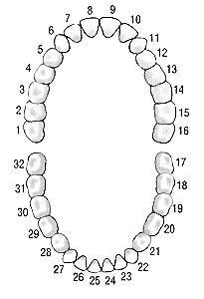

Tell about your experiences with dentists.

Jobs I Have Had

An Application for a Job

EMPLOYMENT APPLICATION

Name_____________________________________________________________________________
Last First Middle
Address___________________________________________________________________________
Street Apartment or P.O. Number
_____________________________________________________________(___)________________
City State Zip Phone
Can you work any day of the week? Yes No
If No, what days can you work? M T W Th F Sat Sun
Can you work any shift? Yes No If no, what hours can you work? _______________________
Have you ever worked for this company? Yes No If yes, where and when? _______________

WORK HISTORY: List all your employers for the last FIVE YEARS beginning with the most current. This information will be verified through reference checks.

Dates Employed |  | Company Name and Address | Supervisor's Name and Phone Number | Your Position and Pay Rate
From | To
Duties:

Reason for Leaving

Dates Employed |  | Company Name and Address | Supervisor's Name and Phone Number | Your Position and Pay Rate
From | To
Duties:

Reason for Leaving

Dates Employed |  | Company Name and Address | Supervisor's Name and Phone Number | Your Position and Pay Rate
From | To
Duties:

Reason for
Leaving

SIGNATURE OF APPLICANT _______________________________________________________ DATE________________

EMERGENCY INFORMATION FORM for EMPLOYEES

EMPLOYEE INFORMATION
Name: | SS#:
Home Address: | Home Phone:
Physician Name: | Phone:
Address:

Dentist Name: | Phone:
Address:

Medical Insurance Information:

Important Medical Information:

My Work History

My Resume

Information for my Resume

Personal Information
Full Name:

City: State:

Phone:

Email:

Career Objective:

Education

School #1
Degree:
Graduation Date:
Name of School:
City: State:
School #2
Degree:
Graduation Date:
Name of School:
City: State:

Employment

Job #1
Start Date - Month: _______Year:____ End Date - Month: ________Year: ____
Position or Job Title: _________________________________
Company Name: _________________________________
City: __________ State: ______
Job Duties: ________________________________________________
__________________________________________________________

Job #2
Start Date - Month: _______Year:____ End Date - Month: ________Year: ____
Position or Job Title: _________________________________
Company Name: _________________________________
City: __________ State: ______
Job Duties: ________________________________________________
__________________________________________________________

Skills
List special, work-related, talents and skills.
- _________________________________
- _________________________________
- _________________________________

